Kaizen Property Management

Why Hire a Property Manager?

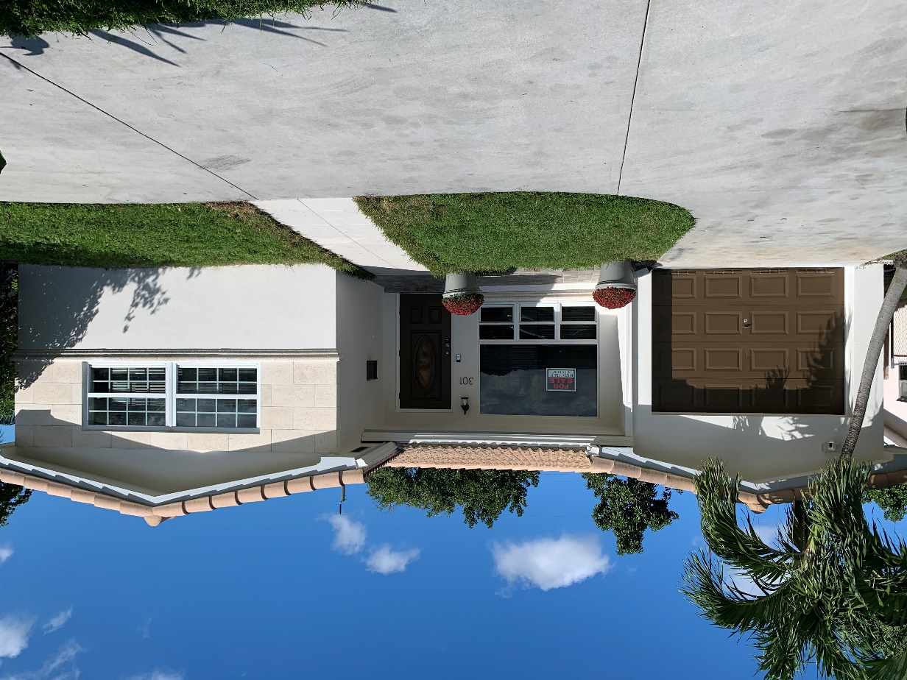

Real Estate Property Manager Areas of

Responsibility

In real estate property management, the property manager or management company has four major areas of responsibility:

1. Marketing and Financial
2. Tenant and Occupancy
3. Facility
4. Administration & Risk Management

The property manager is the owner's partner in maximizing the return on investment of the property through efficient performance of these four functional areas of responsibility. The property management company acts in the best interests of the owner to maintain the property, keep it occupied with tenants, collect rents, budget improvements and maintain records. Many real estate professionals have looked at property management and changed their minds when the scope of the management tasks and record-keeping are fully understood. It's definitely a niche for the more detailed and responsive in the profession.

1. The Financial & Marketing Functions of Real Estate Property Manager

**Marketing and Financial** - Real estate property management involves understanding of operating expenses and budgeting. From this information, appropriate rental rates are set, balanced by the current market and what it will support in the way of rents. A firm knowledge of the area and competitive rental properties is required. The property manager may recommend marketing programs, special promotions and other advertising strategies to the owner in order to maximize occupancy and rental rates. Regular financial reporting to the owners is required. Understanding financial statements, profit and loss, income taxes and budgeting are all very important for the property manager.

**Property management operations budgeting:**

The real estate property management company, in consultation with the owner, will prepare detailed budgets for the day to day operations of the property. This function involves aspects of all the other functional areas, as it allocates funds for their performance. Not only will the income from rents need to be estimated, a reasonable estimate of expenses for the other three functional areas will need to be made. Costs for tenant services, repairs and maintenance, and administration will need to be closely approximated.

**Capital expenditures budgeting:**

Properties that fall into obsolescence will experience lower rents and a less attractive return on investment as the property ages. A long-term budget for capital improvements should be developed. Renovation, remodeling, and more modern appliances will help to maintain and increase rental income in competition with newer properties. Capital improvements are normally not expensed in the years they are done. An accountant can help to set up costing over their useful life. Certain tax advantages could result from financing the improvements.

**Marketing and advertising budgeting:**

Though word of mouth can bring new tenants, effective competition in the marketplace will require a marketing plan and advertising budget. Consistency is quite important in advertising. Develop a budget to fund regular periodic ads in media that have a proven track record in generating tenants. Budgeting for increased marketing when vacancy rates increase is also a prudent plan. Coordinating increased marketing to announce renovation or improvements is also a good strategy.

**Bringing it all together:**

The real estate property management company is the agent of the owner, and should work closely with the owner to maximize rental income and return on investment for the property. The first step in that process, and quite important, is comprehensive budgeting.

A thorough knowledge of competitive properties, their comparative features and rental rates, is imperative. Plan for renovations and improvements and their funding. Be as accurate as possible in estimating ongoing management expenses for repairs, maintenance, and administration. Maximize rental prices in relation to competition and current market conditions.

1. Tenant & Occupancy Management Function of the Property Manager

**Tenant and Occupancy** - Understanding the needs of the tenants is important for this function. Getting them to move in is only the beginning. The property manager must then respond to their requests, monitor their activities as regards the lease requirements, collect rent in a timely manner, and continually assess the tenants' satisfaction as regards the property's amenities versus those of competing rental properties in the area. The unwelcome task of eviction for violations or non-payment is part of this function also.

A property can be nicely designed and in a desired area, but it will not be a profitable rental property if tenants aren't managed properly and occupancy maintained at a high level.

When tenants are not happy, they vacate at the end of their leases, or even sometimes before. Not only does this reduce income due to unpaid rents, it also increases costs for marketing to replace the lost tenants. Effective tenant management involves:

* Good Collection Practices: Collecting rents as a real estate property manager doesn't begin on the date they are due. The process begins when the tenant fills out their rental application. Getting past rental references, performing credit checks, and interviewing the potential tenant, are the first steps in the process of timely collection of rents. If all of this goes well, the

lease agreement becomes the next step in rent collection. The rental or lease agreement should be very clear to set forth:

* + - on what date and time rents are due,
    - where rent is to be paid, and
    - what happens if rent is not paid as required

Sometimes good tenants fall on bad times. The property management company should have a clear understanding with the owner as to how much latitude they can give to a good long term tenant. Beyond that, it's property management's duty to collect rents as stated in the lease agreement. Taking legal action, and even eviction, could be the end result.

* Responsive handling of repairs and maintenance

A rental property will not enjoy long term tenant retention and acceptable return on investment unless it is maintained properly. This involves:

* + preventive and ongoing maintenance;
  + repairs to correct problems or malfunctions; and
  + construction and remodel

1. Facility & Physical Maintenance and

Repairs to Rental Property

**Facility Management** - Property management is also physical management of the structures and outdoor areas. Landscaping, electrical, plumbing, roof, walls, appliances, and much more are all part of the physical property. The property manager must maintain relationships with contractors and repair companies, budget capital expenditures, and monitor the quality of all repairs and maintenance. This function ties in with the financial piece, as some improvements will require significant capital expenditures and budgeting for them. It ties in with tenant and occupancy management because it is important to tenant retention to have well-maintained properties.

A rental property will not enjoy long term tenant retention and acceptable return on investment unless it is maintained properly. This involves:

* preventive and ongoing maintenance;
* repairs to correct problems or malfunctions; and
* construction and remodel

**Preventive and ongoing maintenance** to rental properties requires a thorough knowledge of the property, its needs for upkeep, staffing required to accomplish the tasks and budgeting to accomplish them. The real estate property manager must balance the costs of routine and preventive maintenance with the benefits and desired results. Line items on a property manager's routine maintenance list might include:

* cleaning of common areas;
* landscape maintenance;
* regular service to heating and air conditioning systems;
* periodic inspection of plumbing and electrical items; or
* proper upkeep of wood, roofing & other building components

**Repairs and corrective actions** are required when things break or cease to function as intended. Sometimes the repair is of an emergency nature, such as a heating malfunction in winter, while at other times these repairs can be scheduled and done efficiently in groups. It is the responsibility of the property manager to know the difference and to serve the needs of the tenants while balancing costs. It's also important to take care of small problems before they become large ones.

**Construction and remodel** are a part of facility and building maintenance. Remodel or construction of the structure might be required:

* for special business requirements of a commercial tenant;
* to correct obsolescence of the structure; or
* to accommodate special physical needs of a tenant;
* A real estate property manager can be very skilled at all the other functions of management, but if they drop the ball when it comes to facility maintenance, the property will experience a degradation of condition, loss of tenants, and declining rents.

1. Administration & Risk Management in Real Estate Property Management

**Administration & Risk Management** - This is the files and records part of the property management function. Federal, state and local governments all have some jurisdiction over real estate property management activities. Certain reporting requirements must be met for all of them. Meticulous records for accounting and taxes are a must. For reasons of liability, all activities and tenant interaction must be recorded and maintained for specified periods. Though also related to financial functions, there are very rigid requirements in most states, including Florida, for the handling of funds paid by renters for disbursement to owners.

Administration and risk management is a critical component of real estate property management. The record-keeping function must be carefully managed and, the greater the level of detail, the better the likely results. This function involves all the others, as:

* the marketing & financial function requires records of expenditures and income, as well as tax records, advertising invoices and more,
* tenant management involves records of all their requests, rental payment history and rules violations, and
* facility maintenance & repairs require maintenance schedules, repair records for warranty, and employee and subcontractor personnel records.

The risk management component is of course very important. A large disaster can threaten the survival of the property economically. The records kept are a part of this, as any legal action taken by others can be thwarted if there are detailed records that refute their claims.

A part of risk management is determination of risk versus reward. A good example is a hot tub or swimming pool on the property. The property manager and owner must balance the value of the pool with the risks incurred. When a risk such as this is identified, there are three ways in which it can be addressed:

**1. Avoidance** - The decision can be made to remove the hot tub or pool, as the additional rental income is not worth the cost of insurance or the risks involved.

**2. Control** - If the hot tub is retained, perhaps a coded lock and fence would be installed to keep out younger children.

**3. Risk Transfer** - The most prevalent way of dealing with risk is to purchase insurance to transfer the risk to the insurer.

The successful property manager will plan for problems, keep excellent files and records of every activity, and continually assess these functions to determine if change is necessary.

Credit to Mr. James Kimmons  
Format:Mr. Omar A. Capellan